**DLD LAB 08 – Home Tasks**

**Task 01(b):**

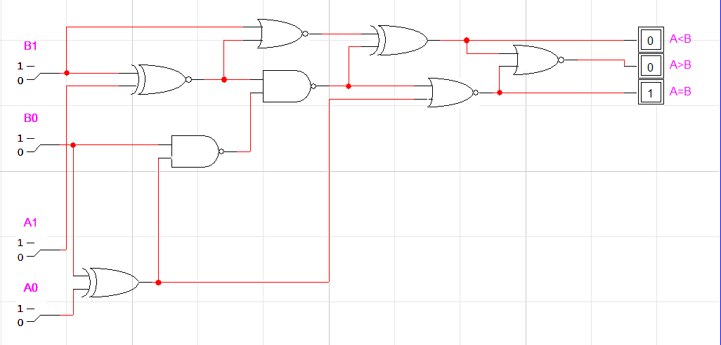

**Truth Table**

|  |  |  |  |  |  |  |
| --- | --- | --- | --- | --- | --- | --- |
| **Input** | | | | **Output** | | |
| **A1** | **A0** | **B1** | **B0** | **A>B** | **A=B** | **A<B** |
| 0 | 0 | 0 | 0 | 0 | 1 | 0 |
| 0 | 0 | 0 | 1 | 0 | 0 | 1 |
| 0 | 0 | 1 | 0 | 0 | 0 | 1 |
| 0 | 0 | 1 | 1 | 0 | 0 | 1 |
| 0 | 1 | 0 | 0 | 1 | 0 | 0 |
| 0 | 1 | 0 | 1 | 0 | 1 | 0 |
| 0 | 1 | 1 | 0 | 0 | 0 | 1 |
| 0 | 1 | 1 | 1 | 0 | 0 | 1 |
| 1 | 0 | 0 | 0 | 1 | 0 | 0 |
| 1 | 0 | 0 | 1 | 1 | 0 | 0 |
| 1 | 0 | 1 | 0 | 0 | 1 | 0 |
| 1 | 0 | 1 | 1 | 0 | 0 | 1 |
| 1 | 1 | 0 | 0 | 1 | 0 | 0 |
| 1 | 1 | 0 | 1 | 1 | 0 | 0 |
| 1 | 1 | 1 | 0 | 1 | 0 | 0 |
| 1 | 1 | 1 | 1 | 0 | 1 | 0 |

**Task 03:**

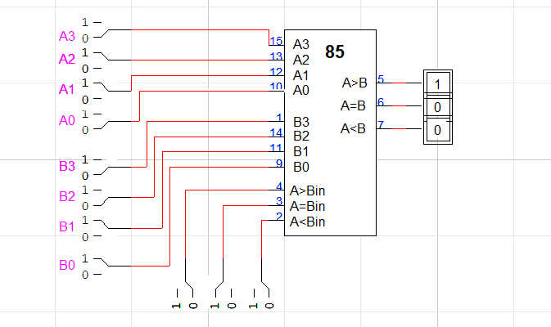

**Task 04:**

